Next Gen(D)eration Leadership Collective Peer-to-Peer Mentoring ‘Pods’ Guidance

Introduction

About the Next Gen(D)eration Leadership Collective
The Next Gen(D)eration Leadership Collective is an initiative that builds on the experience of professional women working in the field of nutrition and food systems globally. Our vision is an equitable food system for a well-nourished world. Our purpose is advancing the 8 courageous leadership practices, outlined in the Manifesto for Leadership, to redress power imbalances in nutrition and food systems, through various activities, including pods and forums. This document will describe the function and structure of the pods.

What are Pods?
Pods are small, informal virtual groups of 4-6 mid to senior career women working in nutrition and food systems. These groups are participant-led and self-managed by pod members. Participants are encouraged to meet at least once a month.

Aim and Objectives of the Pods
The aim of the pods is to enable peer-to-peer mentoring among mid- and senior-career women through focused discussions around the leadership challenges they face in their spaces of influence and how to apply the 8 courageous leadership practices (see below).
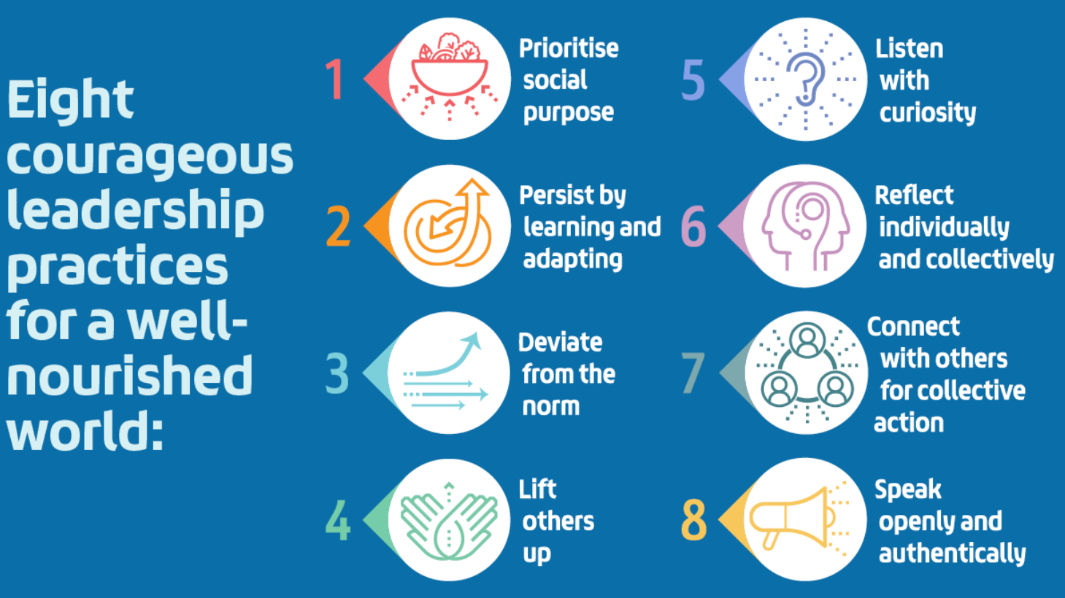

The objectives of the pods therefore are:
- To provide a safe space where women come together, feel valued through empathy, solidarity, patience, respect and trust.
- To foster collective support where women share responsibilities and experiences, offer advice and encourage each other to adopt the 8 courageous leadership practices to navigate challenges.
- To foster collective efficacy where the group believes in their combined ability to effect change and overcome leadership challenges together.
We hope we will be able to support each other to learn and grow together as a Collective!

Duration of the pods
The pods are designed to run for two years. After this period, participants can express their interest in continuing and may choose to remain in the same pod or be assigned to a new pod to keep the momentum going.

Planning your pods
The information set out in this document has been put together to help with the management and running of your pods. However, these are just our suggestions, and your group should feel free to take any approach that works best for you.

Setting up your pod
- Scheduling tools: To make scheduling easier across various time zones, consider using this tool: https://www.timeanddate.com/worldclock/meeting.html. Once you have potential times, use doodle to find a meeting time that works for everyone.
- Pod kickoff: During the first meeting, members get to know each other with icebreakers, share their personal/professional story and what they are hoping to get out of the pods.

Pod Administration
- Scheduling sessions: Appoint a member to schedule the series of pod meetings.
- Meeting chair: Each member should ideally chair at least one session to promote leadership development. Here are some ideas on how to choose the chair: rotational basis, voluntary basis, random selection…
- Record keeper: We encourage rotating this role, along with other responsibilities, so everyone gets involved.
- Ground rules: Establish a code of conduct for your pod to promote respectful and productive discussions. Record it in your summary notes for future reference.

3. Designing Your Pod Meetings
- Frequency & length: Discuss how often you would like to meet and determine the length of your sessions.
- Meeting platform: Agree on a platform (e.g., Zoom, Teams) for conducting your online pod meetings.
- Agenda setting: To help with selecting themes or topics for each session, you can refer to the following Topic Bank ChangeMakers Peer-to-Peer Mentoring Pods: https://drive.google.com/file/d/1SVZ-GdfF082kUJHdH3Zo08HGcAcgKnUD/view?usp=drive_link

4. Pod Session Structure
- Themed discussions: Each pod session can be structured around a specific theme, topic or case.
- Sharing & learning: During sessions, members are encouraged to share experiences, context, challenges, solutions, and lessons learned based on the chosen theme/case.
Considering power imbalances in the discussion: We suggest you consider reflecting on whether particular power imbalances were at play in the case presented.
- In what ways do power imbalances influence the challenge?
- Are there specific leadership practices that could mitigate the power imbalances identified? You could consider structural barriers related to imbalances that could include but not limited to economic, organizational politics, region, gender, ethnicity/race, seniority, age, socioeconomic status, education and credentials, language and communication, or any intersection of the above (further guiding questions to stimulate the discussion can be found in the Topic Bank resource).

5. Suggested format for discussion on themes/challenges using InterVision or a case-clinic approach
One or two people bring a topic/challenge/case they need support with. The group then helps them through the following format:
Case giver shares context/challenge/situation
Group asks clarifying questions
Reflective pause: everyone turns off their camera to quietly reflect on insights, suggestions, solutions and open questions, then share their reflections with the case-giver, leading into a discussion
Case-giver summarizes main takeaways + next steps -suggestion: document this in a running Google Drive file.
Journalling time for all to capture any learnings

6. Personal Growth
- Courageous Leadership Self-Assessment: We encourage everyone to complete the Courageous Leadership Self-Assessment tool, which is a confidential self-reflection tool.
- Reflection & journaling: We encourage each member to reflect upon and journal any learnings or thoughts related to preparing for or after your pod discussions that you have along your learning journey together.

For further information on this approach see: https://www.toolshero.com/communicationhttps://www.toolshero.com/communication-methods/intervision/methods/intervision/

